Figure 6
Connections over 200 kbps in at Least One Direction 2015-2019
(In thousands)

 | 2015 |  | 2016 |  | 2017 |  | 2018 |  | 2019
Technology | Jun | Dec | Jun | Dec | Jun | Dec | Jun | Dec | Jun
Total | 357,509 | 375,790 | 395,496 | 404,849 | 408,692 | 420,838 | 428,864 | 441,288 | 448,867
Total Fixed | 100,075 | 102,111 | 103,980 | 105,593 | 106,130 | 108,065 | 109,087 | 110,756 | 112,663
Mobile Wireless | 257,434 | 273,679 | 291,516 | 299,256 | 302,562 | 312,773 | 319,776 | 330,532 | 336,204

Figure 7
Residential Connections over 200 kbps in at Least One Direction 2015-2019
(In thousands)

 | 2015 |  | 2016 |  | 2017 |  | 2018 |  | 2019
Technology | Jun | Dec | Jun | Dec | Jun | Dec | Jun | Dec | Jun
Total | 306,292 | 322,557 | 330,987 | 337,978 | 341,094 | 351,966 | 358,867 | 368,512 | 373,131
Total Fixed | 91,439 | 93,434 | 95,001 | 96,607 | 97,071 | 98,845 | 99,758 | 101,321 | 103,043
Mobile Wireless | 214,853 | 229,122 | 235,985 | 241,371 | 244,022 | 253,121 | 259,109 | 267,191 | 270,087

Some previously published data may have been revised. Figures may not sum to totals due to rounding.

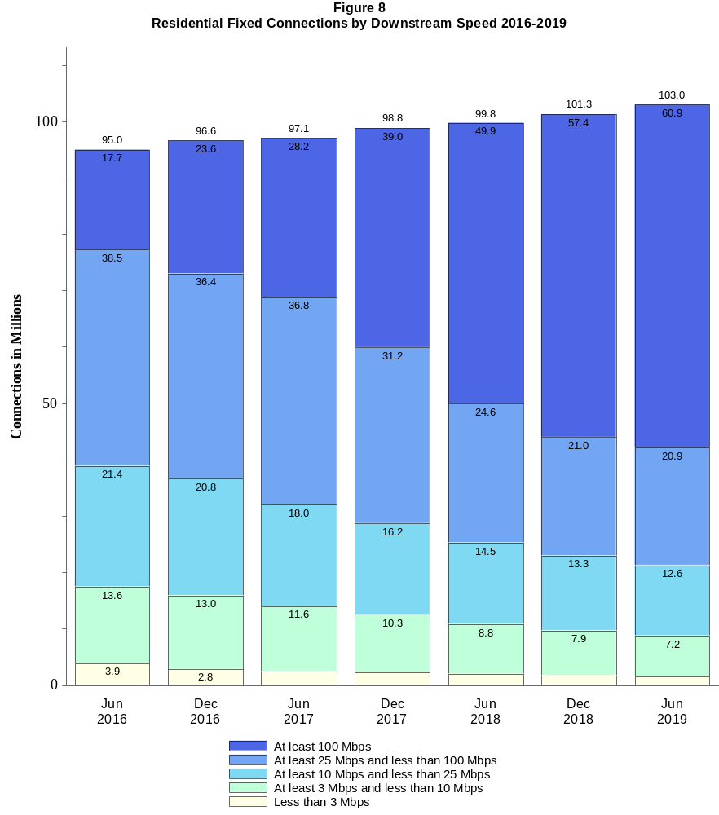

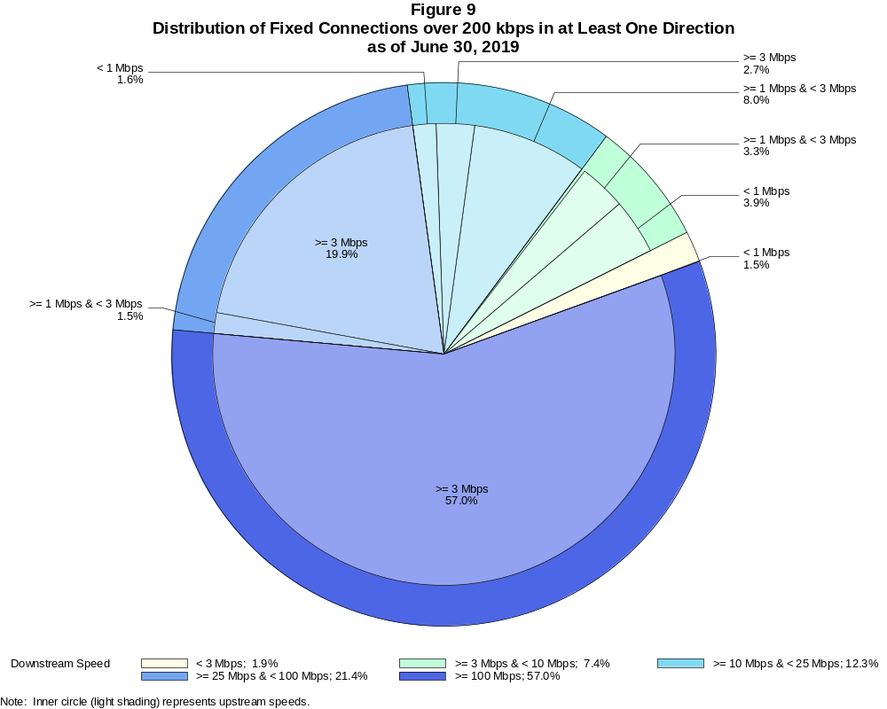

Fixed Connections over 200 kbps in at Least One Direction (in thousands)

 | Downstream Speed
Upstream Speed | Less than 3 Mbps | At least 3 Mbps  and less than 10 Mbps | At least 10 Mbps  and less than 25 Mbps | At least 25 Mbps  and less than 100 Mbps | At least 100 Mbps | Total
Less than 1 Mbps | 1,663 | 4,377 | 1,821 | # | # | 7,862
At least 1 Mbps & Less than 3 Mbps | 426 | 3,702 | 9,065 | 1,641 | 8 | 14,842
At least 3 Mbps | 3 | 270 | 3,013 | 22,466 | 64,208 | 89,960
Total | 2,092 | 8,349 | 13,899 | 24,107 | 64,216 | 112,663

Percentages

Less than 1 Mbps | 1.5 | 3.9 | 1.6 | 0.0 | 0.0 | 7.0
At least 1 Mbps & Less than 3 Mbps | 0.4 | 3.3 | 8.0 | 1.5 | 0.0 | 13.2
At least 3 Mbps | 0.0 | 0.2 | 2.7 | 19.9 | 57.0 | 79.8
Total | 1.9 | 7.4 | 12.3 | 21.4 | 57.0 | 100.0

Note: Figures may not sum to totals due to rounding. # = Rounds to zero.
Source: FCC Form 477.

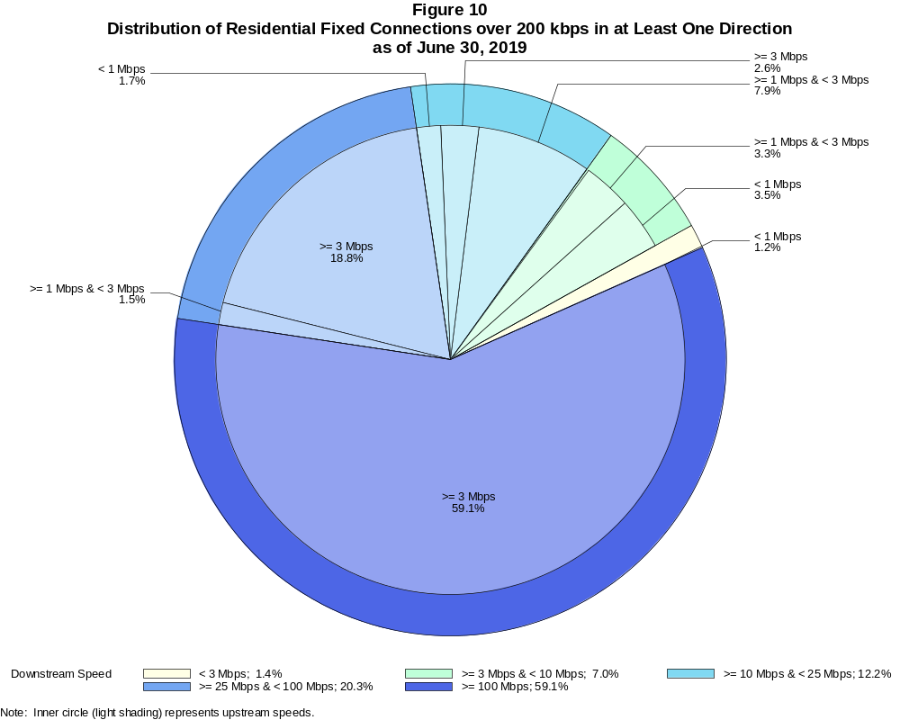

Residential Fixed Connections over 200 kbps in at Least One Direction (in thousands)

 | Downstream Speed
Upstream Speed | Less than 3 Mbps | At least 3 Mbps  and less than 10 Mbps | At least 10 Mbps  and less than 25 Mbps | At least 25 Mbps  and less than 100 Mbps | At least 100 Mbps | Total
Less than 1 Mbps | 1,243 | 3,658 | 1,708 | # | # | 6,610
At least 1 Mbps & Less than 3 Mbps | 229 | 3,427 | 8,177 | 1,579 | 8 | 13,419
At least 3 Mbps | 2 | 152 | 2,681 | 19,321 | 60,858 | 83,015
Total | 1,474 | 7,237 | 12,566 | 20,900 | 60,866 | 103,043

Percentages

Less than 1 Mbps | 1.2 | 3.5 | 1.7 | 0.0 | 0.0 | 6.4
At least 1 Mbps & Less than 3 Mbps | 0.2 | 3.3 | 7.9 | 1.5 | 0.0 | 13.0
At least 3 Mbps | 0.0 | 0.1 | 2.6 | 18.8 | 59.1 | 80.6
Total | 1.4 | 7.0 | 12.2 | 20.3 | 59.1 | 100.0

Note: Figures may not sum to totals due to rounding. # = Rounds to zero.
Source: FCC Form 477.

Figure 11
Connections over 200 kbps in at Least One Direction by Technology 2015-2019
(In thousands)

 | 2015 |  | 2016 |  | 2017 |  | 2018 |  | 2019
Technology | Jun | Dec | Jun | Dec | Jun | Dec | Jun | Dec | Jun
Total | 357,509 | 375,790 | 395,496 | 404,849 | 408,692 | 420,838 | 428,864 | 441,288 | 448,867
Total Fixed | 100,075 | 102,111 | 103,980 | 105,593 | 106,130 | 108,065 | 109,087 | 110,756 | 112,663
aDSL | 29,351 | 28,134 | 27,488 | 26,527 | 25,505 | 24,193 | 23,074 | 21,934 | 20,419
sDSL | 77 | 60 | 55 | 42 | 44 | 28 | 28 | 20 | 17
Other Wireline¹ | 642 | 637 | 622 | 599 | 619 | 581 | 558 | 555 | 515
Cable Modem | 57,244 | 59,706 | 61,456 | 63,325 | 64,060 | 66,196 | 67,165 | 68,871 | 70,772
FTTP² | 9,646 | 10,450 | 11,087 | 11,986 | 12,831 | 13,890 | 14,889 | 15,928 | 17,408
Satellite | 2,058 | 2,071 | 2,079 | 1,864 | 1,826 | 1,872 | 1,939 | 1,971 | 1,984
Fixed Wireless | 1,056 | 1,054 | 1,193 | 1,250 | 1,245 | 1,306 | 1,434 | 1,477 | 1,549
Mobile Wireless | 257,434 | 273,679 | 291,516 | 299,256 | 302,562 | 312,773 | 319,776 | 330,532 | 336,204

¹ Power Line and Other are summarized with Other Wireline to maintain firm confidentiality. See Technical Notes at the end of the report for a description of
Form 477 technology categories and other reporting requirements.
² Fiber to the premises.
Some previously published data may have been revised. Figures may not sum to totals due to rounding.

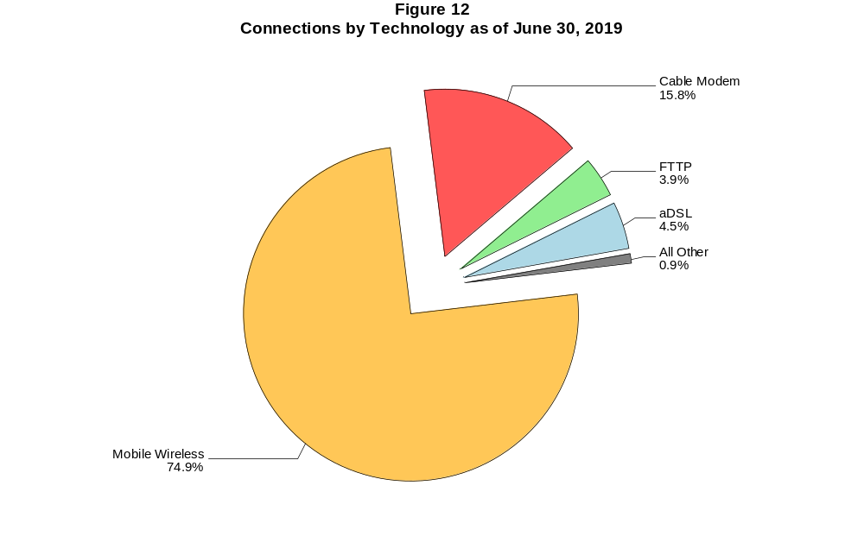

Figure 13
Residential Connections over 200 kbps in at Least One Direction by Technology 2015-2019
(In thousands)

 | 2015 |  | 2016 |  | 2017 |  | 2018 |  | 2019
Technology | Jun | Dec | Jun | Dec | Jun | Dec | Jun | Dec | Jun
Total | 306,292 | 322,557 | 330,987 | 337,978 | 341,094 | 351,966 | 358,867 | 368,512 | 373,131
Total Fixed | 91,439 | 93,434 | 95,001 | 96,607 | 97,071 | 98,845 | 99,758 | 101,321 | 103,043
aDSL | 26,157 | 25,139 | 24,486 | 23,691 | 22,774 | 21,653 | 20,671 | 19,692 | 18,280
sDSL | 18 | 16 | 10 | 8 | 12 | 9 | 9 | 4 | 4
Other Wireline¹ | 59 | 54 | 51 | 32 | 74 | 67 | 74 | 74 | 61
Cable Modem | 53,544 | 55,799 | 57,358 | 59,145 | 59,687 | 61,567 | 62,320 | 63,802 | 65,476
FTTP² | 8,842 | 9,592 | 10,140 | 10,956 | 11,776 | 12,702 | 13,663 | 14,632 | 16,025
Satellite | 1,875 | 1,891 | 1,897 | 1,676 | 1,637 | 1,688 | 1,751 | 1,787 | 1,805
Fixed Wireless | 944 | 943 | 1,059 | 1,100 | 1,112 | 1,158 | 1,270 | 1,330 | 1,393
Mobile Wireless | 214,853 | 229,122 | 235,985 | 241,371 | 244,022 | 253,121 | 259,109 | 267,191 | 270,087

¹ Power Line and Other are summarized with Other Wireline to maintain firm confidentiality. See Technical Notes at the end of the report for a description of
Form 477 technology categories and other reporting requirements.
² Fiber to the premises.
Some previously published data may have been revised. Figures may not sum to totals due to rounding.

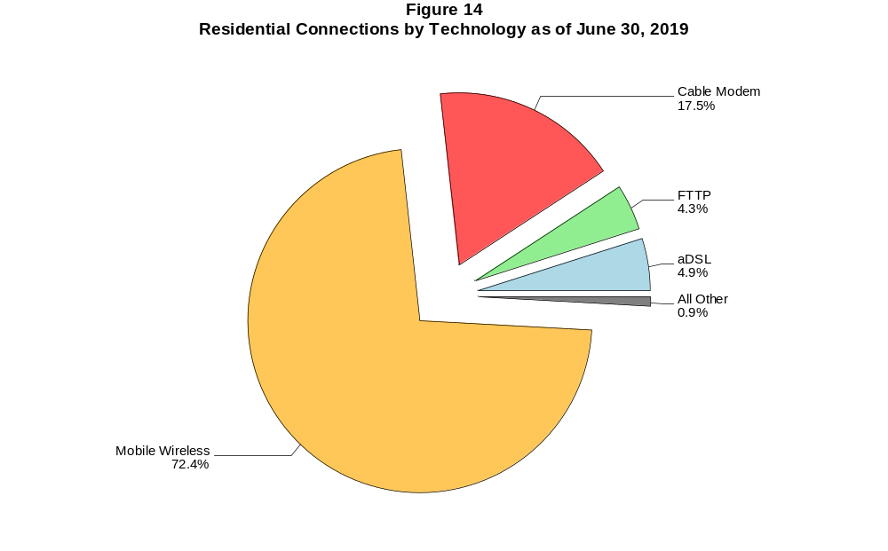

Figure 15
Fixed Connections at Least 3 Mbps Downstream and 768 kbps Upstream by Technology 2015-2019
(In thousands)

 | 2015 |  | 2016 |  | 2017 |  | 2018 |  | 2019
Technology | Jun | Dec | Jun | Dec | Jun | Dec | Jun | Dec | Jun
Total | 88,952 | 92,291 | 95,446 | 98,677 | 100,009 | 101,943 | 103,970 | 106,101 | 108,455
aDSL | 20,947 | 20,744 | 21,147 | 21,042 | 20,621 | 19,257 | 18,876 | 18,124 | 17,000
sDSL | 24 | 20 | 20 | 20 | 24 | 16 | 17 | 11 | 9
Other Wireline¹ | 279 | 314 | 321 | 311 | 340 | 352 | 360 | 370 | 347
Cable Modem | 55,819 | 58,423 | 60,343 | 62,855 | 63,719 | 65,906 | 66,961 | 68,695 | 70,608
FTTP² | 9,511 | 10,335 | 10,975 | 11,887 | 12,738 | 13,783 | 14,798 | 15,836 | 17,320
Satellite | 1,690 | 1,744 | 1,775 | 1,609 | 1,586 | 1,563 | 1,722 | 1,770 | 1,801
Fixed Wireless | 682 | 712 | 865 | 954 | 981 | 1,065 | 1,237 | 1,296 | 1,370

¹ Power Line and Other are summarized with Other Wireline to maintain firm confidentiality. See Technical Notes at the end of the report for a description of Form
477 technology categories and other reporting requirements.
² Fiber to the premises.
# = Rounds to zero.
Some previously published data may have been revised. Figures may not sum to totals due to rounding.

Figure 16
Residential Fixed Connections at Least 3 Mbps Downstream and 768 kbps Upstream by Technology 2015-2019
(In thousands)

 | 2015 |  | 2016 |  | 2017 |  | 2018 |  | 2019
Technology | Jun | Dec | Jun | Dec | Jun | Dec | Jun | Dec | Jun
Total | 82,320 | 85,439 | 88,198 | 91,258 | 92,355 | 93,987 | 95,756 | 97,675 | 99,780
aDSL | 18,988 | 18,866 | 19,207 | 19,133 | 18,719 | 17,480 | 17,128 | 16,462 | 15,392
sDSL | 1 | 2 | 2 | 2 | 7 | 6 | 6 | 2 | 2
Other Wireline¹ | 45 | 47 | 49 | 31 | 73 | 66 | 72 | 71 | 60
Cable Modem | 52,254 | 54,650 | 56,353 | 58,784 | 59,411 | 61,335 | 62,167 | 63,670 | 65,364
FTTP² | 8,750 | 9,512 | 10,063 | 10,883 | 11,704 | 12,616 | 13,590 | 14,560 | 15,955
Satellite | 1,682 | 1,734 | 1,764 | 1,596 | 1,571 | 1,545 | 1,700 | 1,745 | 1,775
Fixed Wireless | 600 | 628 | 759 | 830 | 870 | 939 | 1,092 | 1,164 | 1,232

¹ Power Line and Other are summarized with Other Wireline to maintain firm confidentiality. See Technical Notes at the end of the report for a description of Form
477 technology categories and other reporting requirements.
² Fiber to the premises.
# = Rounds to zero.
Some previously published data may have been revised. Figures may not sum to totals due to rounding.

Figure 17
Fixed Connections at Least 10 Mbps Downstream and 1 Mbps Upstream by Technology 2015-2019
(In thousands)

 | 2015 |  | 2016 |  | 2017 |  | 2018 |  | 2019
Technology | Jun | Dec | Jun | Dec | Jun | Dec | Jun | Dec | Jun
Total | 72,667 | 76,886 | 80,397 | 84,038 | 86,886 | 90,609 | 94,071 | 97,277 | 100,401
aDSL | 9,471 | 9,799 | 10,349 | 10,810 | 11,321 | 11,598 | 11,822 | 11,864 | 11,342
sDSL | 9 | 8 | 8 | 10 | 14 | 9 | 11 | 6 | 5
Other Wireline¹ | 176 | 197 | 203 | 209 | 246 | 262 | 271 | 290 | 274
Cable Modem | 52,658 | 55,710 | 57,951 | 60,349 | 61,704 | 63,978 | 65,808 | 67,705 | 69,719
FTTP² | 8,834 | 9,528 | 10,088 | 10,935 | 11,811 | 12,869 | 13,898 | 14,983 | 16,482
Satellite | 1,298 | 1,393 | 1,467 | 1,342 | 1,373 | 1,402 | 1,595 | 1,677 | 1,726
Fixed Wireless | 221 | 252 | 330 | 383 | 418 | 491 | 666 | 752 | 854

¹ Power Line and Other are summarized with Other Wireline to maintain firm confidentiality. See Technical Notes at the end of the report for a description of
Form 477 technology categories and other reporting requirements.
² Fiber to the premises.
# = Rounds to zero.
Some previously published data may have been revised. Figures may not sum to totals due to rounding.

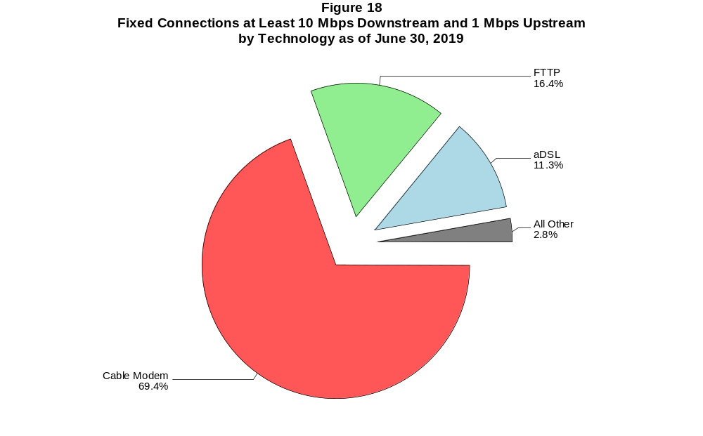

Figure 19
Residential Fixed Connections at Least 10 Mbps Downstream and 1 Mbps Upstream
by Technology 2015-2019
(In thousands)

 | 2015 |  | 2016 |  | 2017 |  | 2018 |  | 2019
Technology | Jun | Dec | Jun | Dec | Jun | Dec | Jun | Dec | Jun
Total | 67,898 | 71,784 | 74,841 | 78,201 | 80,671 | 84,163 | 86,973 | 89,849 | 92,623
aDSL | 8,743 | 9,069 | 9,526 | 9,963 | 10,415 | 10,657 | 10,862 | 10,904 | 10,369
sDSL | # | 1 | 2 | 2 | 6 | 5 | 6 | 2 | 1
Other Wireline¹ | 38 | 43 | 47 | 30 | 71 | 64 | 65 | 66 | 57
Cable Modem | 49,487 | 52,294 | 54,274 | 56,538 | 57,617 | 59,864 | 61,142 | 62,799 | 64,569
FTTP² | 8,144 | 8,776 | 9,248 | 10,004 | 10,835 | 11,762 | 12,741 | 13,754 | 15,164
Satellite | 1,293 | 1,386 | 1,460 | 1,333 | 1,362 | 1,387 | 1,575 | 1,655 | 1,702
Fixed Wireless | 191 | 213 | 283 | 332 | 365 | 425 | 582 | 670 | 762

¹ Power Line and Other are summarized with Other Wireline to maintain firm confidentiality. See Technical Notes at the end of the report for a description of
Form 477 technology categories and other reporting requirements.
² Fiber to the premises.
# = Rounds to zero.
Some previously published data may have been revised. Figures may not sum to totals due to rounding.

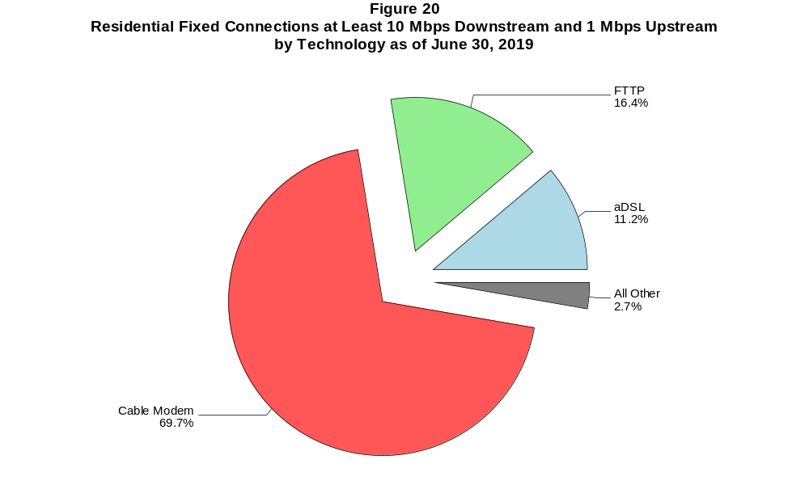

Figure 21
Fixed Connections at Least 25 Mbps Downstream and 3 Mbps Upstream by Technology 2015-2019
(In thousands)

 | 2015 |  | 2016 |  | 2017 |  | 2018 |  | 2019
Technology | Jun | Dec | Jun | Dec | Jun | Dec | Jun | Dec | Jun
Total | 48,767 | 54,338 | 58,765 | 62,933 | 68,280 | 73,875 | 78,952 | 82,944 | 86,674
aDSL | 762 | 938 | 1,239 | 1,476 | 2,530 | 3,586 | 4,298 | 4,838 | 4,770
sDSL | * | * | * | * | * | * | * | * | *
Other Wireline¹ | 122 | 138 | 155 | 166 | 203 | 219 | 203 | 226 | 230
Cable Modem | 40,979 | 45,530 | 48,696 | 51,740 | 54,829 | 57,870 | 60,859 | 62,869 | 64,945
FTTP² | 6,856 | 7,673 | 8,587 | 9,422 | 10,344 | 11,489 | 12,568 | 13,750 | 15,280
Satellite | * | * | * | * | * | * | * | * | *
Fixed Wireless | 47 | 55 | 72 | 92 | 120 | 143 | 224 | 263 | 321

¹ Power Line and Other are summarized with Other Wireline to maintain firm confidentiality. See Technical Notes at the end of the report for a description of
Form 477 technology categories and other reporting requirements.
² Fiber to the premises.
* = Data withheld to maintain firm confidentiality.
# = Rounds to zero.
Some previously published data may have been revised. Figures may not sum to totals due to rounding.

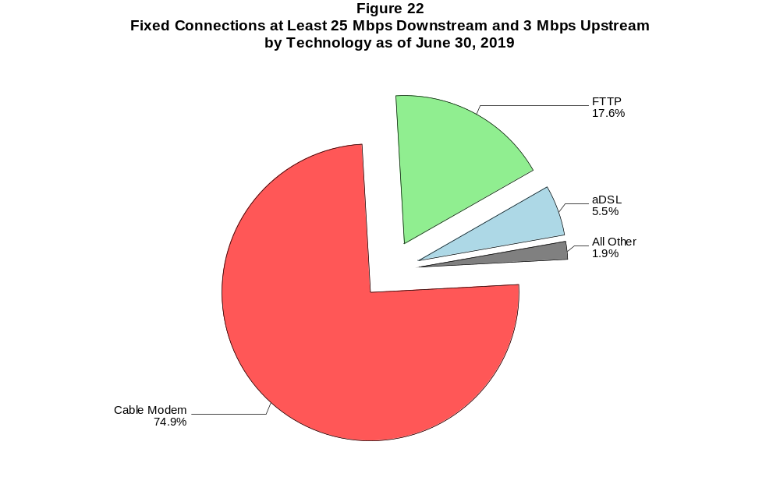

Figure 23
Residential Fixed Connections at Least 25 Mbps Downstream and 3 Mbps Upstream by Technology 2015-2019
(In thousands)

 | 2015 |  | 2016 |  | 2017 |  | 2018 |  | 2019
Technology | Jun | Dec | Jun | Dec | Jun | Dec | Jun | Dec | Jun
Total | 46,532 | 51,812 | 55,729 | 59,518 | 64,520 | 69,447 | 73,288 | 76,852 | 80,179
aDSL | 727 | 897 | 1,173 | 1,408 | 2,418 | 3,410 | 4,068 | 4,564 | 4,489
sDSL | * | * | * | * | * | * | * | * | *
Other Wireline¹ | 26 | 31 | 41 | 27 | 67 | 59 | 54 | 59 | 53
Cable Modem | 39,416 | 43,746 | 46,527 | 49,300 | 52,154 | 54,748 | 56,620 | 58,331 | 60,132
FTTP² | 6,323 | 7,089 | 7,916 | 8,674 | 9,532 | 10,553 | 11,570 | 12,689 | 14,122
Satellite | * | * | * | * | * | * | * | * | *
Fixed Wireless | 40 | 46 | 57 | 75 | 101 | 119 | 193 | 231 | 280

¹ Power Line and Other are summarized with Other Wireline to maintain firm confidentiality. See Technical Notes at the end of the report for a description of
Form 477 technology categories and other reporting requirements.
² Fiber to the premises.
* = Data withheld to maintain firm confidentiality.
# = Rounds to zero.
Some previously published data may have been revised. Figures may not sum to totals due to rounding.

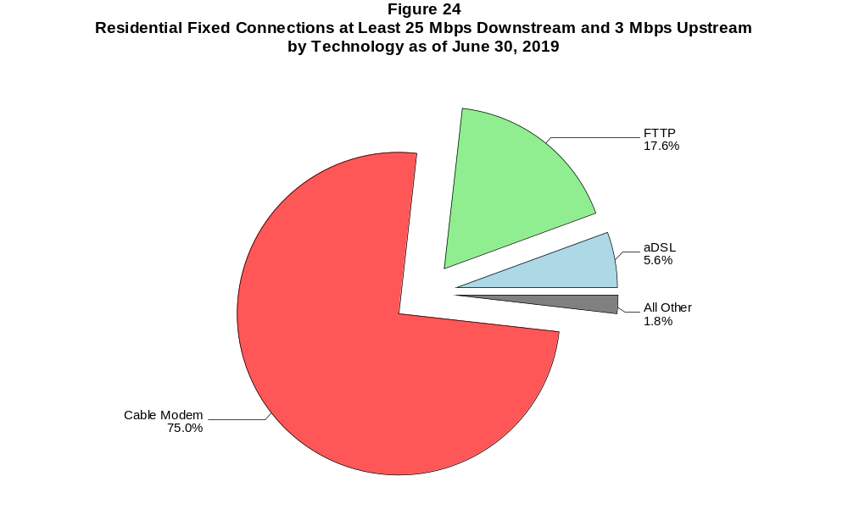

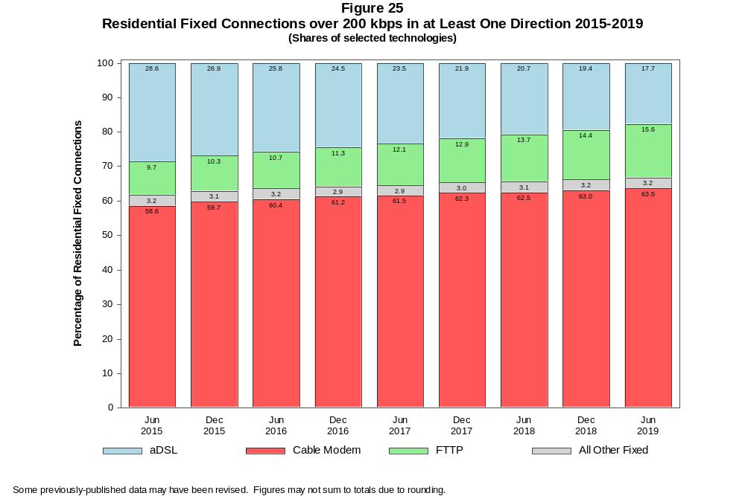

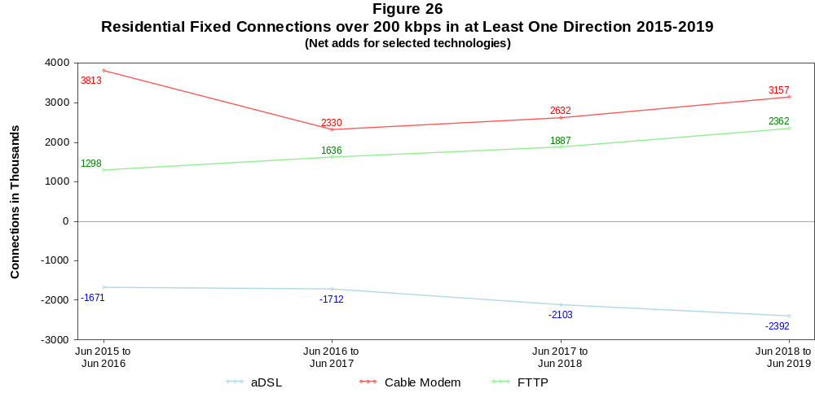

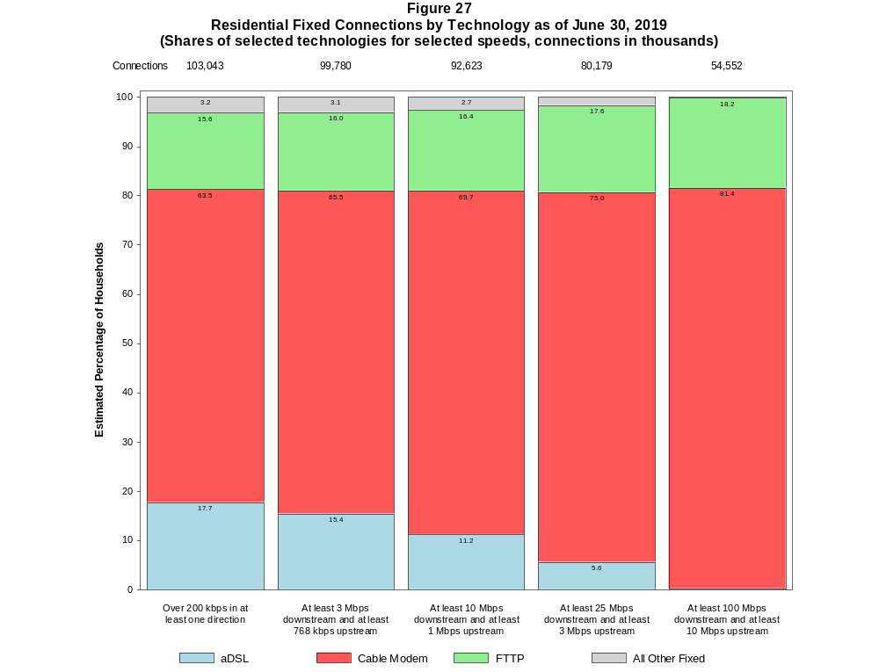

Figure 28
Fixed Connections by Downstream Speed Tier and Technology as of June 30, 2019
(In thousands)

 | Downstream Speed
Technology | Less than  1.5 Mbps | At least 1.5 Mbps  and less than  3 Mbps | At least 3 Mbps  and less than  10 Mbps | At least 10 Mbps  and less than  25 Mbps | At least 25 Mbps  and less than  100 Mbps | At least 100 Mbps | Total
aDSL | 473 | 978 | 6,136 | 7,396 | 5,279 | 157 | 20,419
sDSL | 4 | 4 | 5 | 2 | * | * | 17
Other Wireline¹ | 25 | 142 | 74 | 43 | 29 | 202 | 515
Cable Modem | 28 | 48 | 951 | 3,879 | 12,689 | 53,176 | 70,772
FTTP | 35 | 35 | 557 | 1,449 | 4,741 | 10,591 | 17,408
Satellite | 163 | 17 | 78 | 602 | * | * | 1,984
Fixed Wireless | 57 | 83 | 549 | 527 | 249 | 83 | 1,549
Total | 785 | 1,306 | 8,349 | 13,899 | 24,107 | 64,216 | 112,663

Percentages

aDSL | 0.4 | 0.9 | 5.4 | 6.6 | 4.7 | 0.1 | 18.1
sDSL | 0.0 | 0.0 | 0.0 | 0.0 | * | * | 0.0
Other Wireline¹ | 0.0 | 0.1 | 0.1 | 0.0 | 0.0 | 0.2 | 0.5
Cable Modem | 0.0 | 0.0 | 0.8 | 3.4 | 11.3 | 47.2 | 62.8
FTTP | 0.0 | 0.0 | 0.5 | 1.3 | 4.2 | 9.4 | 15.5
Satellite | 0.1 | 0.0 | 0.1 | 0.5 | * | * | 1.8
Fixed Wireless | 0.1 | 0.1 | 0.5 | 0.5 | 0.2 | 0.1 | 1.4
Total | 0.7 | 1.2 | 7.4 | 12.3 | 21.4 | 57.0 | 100.0

¹ Power Line and Other are summarized with Other Wireline to maintain firm confidentiality. See Technical Notes at the end of the report for a description of Form 477 technology categories
and other reporting requirements.
# = Rounds to Zero.
* = Data withheld to maintain firm confidentiality.
Note: Figures may not sum to totals due to rounding.
Source: FCC Form 477.

Figure 29
Residential Fixed Connections by Downstream Speed Tier and Technology as of June 30, 2019
(In thousands)

 | Downstream Speed
Technology | Less than  1.5 Mbps | At least 1.5 Mbps  and less than  3 Mbps | At least 3 Mbps  and less than  10 Mbps | At least 10 Mbps  and less than  25 Mbps | At least 25 Mbps  and less than  100 Mbps | At least 100 Mbps | Total
aDSL | 420 | 791 | 5,314 | 6,639 | 4,970 | 145 | 18,280
sDSL | 2 | 1 | # | # | * | * | 4
Other Wireline¹ | # | 1 | 3 | 5 | 9 | 43 | 61
Cable Modem | 22 | 30 | 832 | 3,556 | 10,378 | 50,658 | 65,476
FTTP | 28 | 27 | 512 | 1,290 | 4,223 | 9,945 | 16,025
Satellite | 25 | 4 | 74 | 599 | * | * | 1,805
Fixed Wireless | 49 | 75 | 502 | 476 | 222 | 68 | 1,393
Total | 545 | 930 | 7,237 | 12,566 | 20,900 | 60,866 | 103,043

Percentages

aDSL | 0.4 | 0.8 | 5.2 | 6.4 | 4.8 | 0.1 | 17.7
sDSL | 0.0 | 0.0 | 0.0 | 0.0 | * | * | 0.0
Other Wireline¹ | 0.0 | 0.0 | 0.0 | 0.0 | 0.0 | 0.0 | 0.1
Cable Modem | 0.0 | 0.0 | 0.8 | 3.5 | 10.1 | 49.2 | 63.5
FTTP | 0.0 | 0.0 | 0.5 | 1.3 | 4.1 | 9.7 | 15.6
Satellite | 0.0 | 0.0 | 0.1 | 0.6 | * | * | 1.8
Fixed Wireless | 0.0 | 0.1 | 0.5 | 0.5 | 0.2 | 0.1 | 1.4
Total | 0.5 | 0.9 | 7.0 | 12.2 | 20.3 | 59.1 | 100.0

¹ Power Line and Other are summarized with Other Wireline to maintain firm confidentiality. See Technical Notes at the end of the report for a description of Form 477 technology categories
and other reporting requirements.
# = Rounds to Zero.
* = Data withheld to maintain firm confidentiality.
Note: Figures may not sum to totals due to rounding.
Source: FCC Form 477.

Figure 30
Nationwide Number of Providers of Connections over 200 kbps in at Least One Direction
by Technology 2015-2019

 | 2015 |  | 2016 |  | 2017 |  | 2018 |  | 2019
Technology | Jun | Dec | Jun | Dec | Jun | Dec | Jun | Dec | Jun
aDSL | 792 | 778 | 769 | 774 | 768 | 743 | 738 | 720 | 717
sDSL | 177 | 179 | 171 | 160 | 161 | 150 | 136 | 125 | 122
Other Wireline¹ | 240 | 250 | 244 | 236 | 243 | 235 | 249 | 241 | 223
Cable Modem | 393 | 392 | 388 | 385 | 384 | 383 | 372 | 379 | 381
FTTP | 931 | 990 | 1,017 | 1,066 | 1,103 | 1,147 | 1,183 | 1,259 | 1,304
Satellite | 10 | 10 | 6 | 6 | 5 | 6 | 6 | 6 | 6
Fixed Wireless | 949 | 983 | 1,027 | 1,071 | 1,095 | 1,160 | 1,188 | 1,229 | 1,237
Mobile Wireless | 100 | 96 | 99 | 98 | 98 | 83 | 73 | 71 | 70
Total | 1,881 | 1,917 | 1,957 | 2,000 | 2,030 | 2,090 | 2,129 | 2,198 | 2,207

¹ For this Figure, the categories Power Line and All Other were combined with Other Wireline.
Multiple Form 477 filers within a holding company structure count as one provider. * = 1-3 providers.
Some previously published data may have been revised.

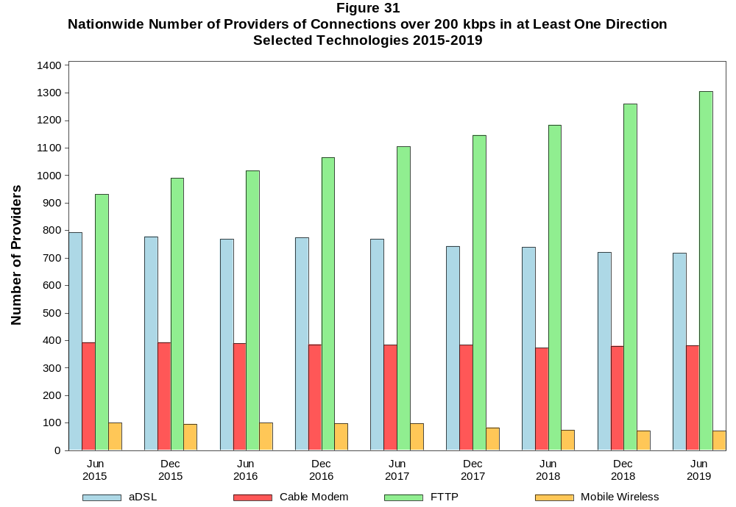

Figure 32
Residential Fixed Connections and Households by State as of June 30, 2019
(Connections and households, in thousands)

 |  | At least 200 kbps in  at least One Direction |  | At least 10 Mbps Down  and 1 Mbps Up |  | At least 25 Mbps Down  and 3 Mbps Up |  | At least 100 Mbps Down  and 10 Mbps Up
State | Households | Connections | Subscribership  Ratio | Connections | Subscribership  Ratio | Connections | Subscribership  Ratio | Connections | Subscribership  Ratio
Alabama | 1,868 | 1,406 | 0.75 | 1,194 | 0.64 | 967 | 0.52 | 701 | 0.38
Alaska | 253 | 203 | 0.80 | 175 | 0.69 | 127 | 0.50 | * | *
American Samoa | 10 | * | * | * | * | * | * | 0 | 0.00
Arizona | 2,571 | 2,196 | 0.85 | 1,882 | 0.73 | 1,651 | 0.64 | 1,100 | 0.43
Arkansas | 1,158 | 773 | 0.67 | 616 | 0.53 | 439 | 0.38 | 241 | 0.21
California | 13,044 | 11,548 | 0.89 | 10,666 | 0.82 | 9,345 | 0.72 | 6,038 | 0.46
Colorado | 2,149 | 1,966 | 0.91 | 1,689 | 0.79 | 1,539 | 0.72 | 675 | 0.31
Connecticut | 1,371 | 1,241 | 0.91 | 1,163 | 0.85 | 973 | 0.71 | 663 | 0.48
Delaware | 363 | 351 | 0.97 | 340 | 0.93 | 327 | 0.90 | 181 | 0.50
District of Columbia | 284 | 256 | 0.90 | 245 | 0.86 | 231 | 0.81 | 146 | 0.51
Florida | 7,736 | 7,297 | 0.94 | 6,812 | 0.88 | 5,924 | 0.77 | 4,539 | 0.59
Georgia | 3,759 | 3,173 | 0.84 | 2,850 | 0.76 | 2,320 | 0.62 | 1,711 | 0.46
Guam | 42 | * | * | * | * | * | * | * | *
Hawaii | 459 | 464 | 1.01 | 443 | 0.96 | * | * | * | *
Idaho | 630 | 519 | 0.82 | 367 | 0.58 | 292 | 0.46 | 114 | 0.18
Illinois | 4,846 | 3,925 | 0.81 | 3,562 | 0.74 | 2,852 | 0.59 | 2,073 | 0.43
Indiana | 2,570 | 2,023 | 0.79 | 1,759 | 0.68 | 1,401 | 0.55 | 970 | 0.38
Iowa | 1,265 | 974 | 0.77 | 764 | 0.60 | 633 | 0.50 | 312 | 0.25
Kansas | 1,129 | 906 | 0.80 | 784 | 0.69 | 616 | 0.55 | 415 | 0.37
Kentucky | 1,735 | 1,382 | 0.80 | 1,177 | 0.68 | 970 | 0.56 | 690 | 0.40
Louisiana | 1,739 | 1,322 | 0.76 | 1,167 | 0.67 | 935 | 0.54 | 639 | 0.37
Maine | 560 | 527 | 0.94 | 443 | 0.79 | 351 | 0.63 | 270 | 0.48
Maryland | 2,205 | 1,984 | 0.90 | 1,909 | 0.87 | 1,782 | 0.81 | 1,040 | 0.47
Massachusetts | 2,617 | 2,416 | 0.92 | 2,319 | 0.89 | 2,233 | 0.85 | 1,309 | 0.50
Michigan | 3,935 | 3,155 | 0.80 | 2,837 | 0.72 | 2,359 | 0.60 | 1,771 | 0.45
Minnesota | 2,186 | 1,812 | 0.83 | 1,519 | 0.70 | 1,328 | 0.61 | 710 | 0.32
Mississippi | 1,104 | 725 | 0.66 | 586 | 0.53 | 392 | 0.36 | 198 | 0.18
Missouri | 2,415 | 1,880 | 0.78 | 1,567 | 0.65 | 1,282 | 0.53 | 951 | 0.39
Montana | 428 | 348 | 0.81 | 276 | 0.65 | 224 | 0.52 | * | *
Nebraska | 759 | 612 | 0.81 | 526 | 0.69 | 436 | 0.57 | 335 | 0.44

Figure 32 - Continued
Residential Fixed Connections and Households by State as of June 30, 2019
(Connections and households, in thousands)

 |  | At least 200 kbps in  at least One Direction |  | At least 10 Mbps Down  and 1 Mbps Up |  | At least 25 Mbps Down  and 3 Mbps Up |  | At least 100 Mbps Down  and 10 Mbps Up
State | Households | Connections | Subscribership  Ratio | Connections | Subscribership  Ratio | Connections | Subscribership  Ratio | Connections | Subscribership  Ratio
Nevada | 1,099 | 963 | 0.88 | 890 | 0.81 | 767 | 0.70 | 610 | 0.56
New Hampshire | 532 | 516 | 0.97 | 476 | 0.90 | 431 | 0.81 | 226 | 0.43
New Jersey | 3,232 | 3,064 | 0.95 | 2,975 | 0.92 | 2,877 | 0.89 | 2,090 | 0.65
New Mexico | 780 | 596 | 0.76 | 439 | 0.56 | 360 | 0.46 | 132 | 0.17
New York | 7,343 | 6,419 | 0.87 | 6,137 | 0.84 | 5,791 | 0.79 | 4,994 | 0.68
North Carolina | 3,965 | 3,448 | 0.87 | 2,983 | 0.75 | 2,691 | 0.68 | 2,179 | 0.55
North Dakota | 318 | 274 | 0.86 | 257 | 0.81 | 238 | 0.75 | 183 | 0.57
Northern Mariana Isl | 16 | * | * | * | * | * | * | * | *
Ohio | 4,676 | 3,788 | 0.81 | 3,351 | 0.72 | 2,748 | 0.59 | 1,974 | 0.42
Oklahoma | 1,480 | 1,082 | 0.73 | 895 | 0.60 | 701 | 0.47 | 439 | 0.30
Oregon | 1,612 | 1,381 | 0.86 | 1,196 | 0.74 | 1,073 | 0.67 | 520 | 0.32
Pennsylvania | 5,053 | 4,208 | 0.83 | 3,809 | 0.75 | 3,436 | 0.68 | 1,939 | 0.38
Puerto Rico | 1,193 | 466 | 0.39 | 321 | 0.27 | 178 | 0.15 | * | *
Rhode Island | 410 | 374 | 0.91 | 369 | 0.90 | 352 | 0.86 | 289 | 0.70
South Carolina | 1,922 | 1,627 | 0.85 | 1,464 | 0.76 | 1,196 | 0.62 | 912 | 0.47
South Dakota | 344 | 279 | 0.81 | 262 | 0.76 | 236 | 0.69 | 161 | 0.47
Tennessee | 2,597 | 2,042 | 0.79 | 1,847 | 0.71 | 1,530 | 0.59 | 1,186 | 0.46
Texas | 9,692 | 8,068 | 0.83 | 7,365 | 0.76 | 6,225 | 0.64 | 4,082 | 0.42
Utah | 977 | 874 | 0.89 | 753 | 0.77 | 661 | 0.68 | 292 | 0.30
Vermont | 260 | 244 | 0.94 | 197 | 0.76 | 156 | 0.60 | 75 | 0.29
Virgin Islands | 43 | 26 | 0.61 | 16 | 0.36 | 9 | 0.20 | * | *
Virginia | 3,151 | 2,662 | 0.84 | 2,439 | 0.77 | 2,257 | 0.72 | 1,483 | 0.47
Washington | 2,848 | 2,528 | 0.89 | 2,225 | 0.78 | 2,028 | 0.71 | 959 | 0.34
West Virginia | 733 | 553 | 0.75 | 432 | 0.59 | 356 | 0.49 | 187 | 0.25
Wisconsin | 2,358 | 1,945 | 0.82 | 1,693 | 0.72 | 1,381 | 0.59 | 1,075 | 0.46
Wyoming | 230 | 191 | 0.83 | 157 | 0.68 | 137 | 0.60 | 95 | 0.41
Total | 122,060 | 103,043 | 0.84 | 92,623 | 0.76 | 80,179 | 0.66 | 54,552 | 0.45

# = Rounds to Zero; * = Data withheld to maintain firm confidentiality.
Note: Figures may not sum to totals due to rounding.
Sources: FCC Form 477 (Connections); 2015-2019 ACS 5-year estimates; Census 2010.

Figure 33
Connections by Type of End User by State as of June 30, 2019
(Connections over 200 kbps in at least one direction, in thousands)

 | Connections |  | Percentages
State | Residential | Business | Residential | Business | Total
Alabama | 5,204 | 1,265 | 80.4 | 19.6 | 6,469
Alaska | 826 | 130 | 86.4 | 13.6 | 955
American Samoa | * | * | * | * | *
Arizona | 7,470 | 1,397 | 84.2 | 15.8 | 8,867
Arkansas | 2,878 | 809 | 78.1 | 21.9 | 3,687
California | 47,305 | 7,971 | 85.6 | 14.4 | 55,276
Colorado | 6,382 | 1,311 | 83.0 | 17.0 | 7,693
Connecticut | 4,135 | 942 | 81.4 | 18.6 | 5,077
Delaware | 1,102 | 220 | 83.4 | 16.6 | 1,321
District of Columbia | 1,006 | 552 | 64.6 | 35.4 | 1,559
Florida | 24,977 | 4,689 | 84.2 | 15.8 | 29,666
Georgia | 11,574 | 2,680 | 81.2 | 18.8 | 14,254
Guam | 189 | 53 | 78.1 | 21.9 | 242
Hawaii | 1,762 | 295 | 85.7 | 14.3 | 2,057
Idaho | 1,805 | 376 | 82.8 | 17.2 | 2,181
Illinois | 14,383 | 3,062 | 82.4 | 17.6 | 17,445
Indiana | 6,944 | 1,525 | 82.0 | 18.0 | 8,469
Iowa | 3,274 | 764 | 81.1 | 18.9 | 4,038
Kansas | 4,976 | 724 | 87.3 | 12.7 | 5,700
Kentucky | 4,881 | 893 | 84.5 | 15.5 | 5,774
Louisiana | 5,236 | 963 | 84.5 | 15.5 | 6,199
Maine | 1,439 | 419 | 77.5 | 22.5 | 1,858
Maryland | 7,259 | 1,305 | 84.8 | 15.2 | 8,563
Massachusetts | 8,455 | 1,679 | 83.4 | 16.6 | 10,134
Michigan | 10,948 | 2,479 | 81.5 | 18.5 | 13,427
Minnesota | 6,181 | 1,399 | 81.5 | 18.5 | 7,580
Mississippi | 3,009 | 581 | 83.8 | 16.2 | 3,590
Missouri | 6,505 | 1,429 | 82.0 | 18.0 | 7,934
Montana | 1,076 | 300 | 78.2 | 21.8 | 1,376
Nebraska | 1,945 | 553 | 77.9 | 22.1 | 2,498
Nevada | 3,439 | 606 | 85.0 | 15.0 | 4,045
New Hampshire | 1,504 | 375 | 80.0 | 20.0 | 1,879
New Jersey | 10,760 | 2,125 | 83.5 | 16.5 | 12,885
New Mexico | 2,145 | 401 | 84.3 | 15.7 | 2,545
New York | 24,817 | 4,582 | 84.4 | 15.6 | 29,399
North Carolina | 10,900 | 2,535 | 81.1 | 18.9 | 13,435
North Dakota | 833 | 223 | 78.9 | 21.1 | 1,057
Northern Mariana Isl | * | * | * | * | *
Ohio | 12,946 | 2,948 | 81.5 | 18.5 | 15,894
Oklahoma | 4,075 | 827 | 83.1 | 16.9 | 4,903
Oregon | 4,637 | 1,006 | 82.2 | 17.8 | 5,643
Pennsylvania | 14,360 | 3,105 | 82.2 | 17.8 | 17,465
Puerto Rico | 3,601 | 410 | 89.8 | 10.2 | 4,011
Rhode Island | 1,155 | 237 | 83.0 | 17.0 | 1,392
South Carolina | 5,243 | 1,200 | 81.4 | 18.6 | 6,443
South Dakota | 873 | 242 | 78.3 | 21.7 | 1,115
Tennessee | 7,072 | 1,735 | 80.3 | 19.7 | 8,808
Texas | 31,803 | 5,731 | 84.7 | 15.3 | 37,535
Utah | 3,133 | 683 | 82.1 | 17.9 | 3,816
Vermont | 684 | 210 | 76.5 | 23.5 | 894
Virgin Islands | 124 | 15 | 89.1 | 10.9 | 139
Virginia | 8,795 | 2,198 | 80.0 | 20.0 | 10,994
Washington | 8,611 | 1,696 | 83.5 | 16.5 | 10,307
West Virginia | 1,638 | 323 | 83.5 | 16.5 | 1,961
Wisconsin | 6,108 | 1,380 | 81.6 | 18.4 | 7,488
Wyoming | 642 | 160 | 80.1 | 19.9 | 802
Total | 373,131 | 75,736 | 83.1 | 16.9 | 448,867

# = Rounds to Zero.
* = Data withheld to maintain firm confidentiality.
Figures may not sum to totals due to rounding.
Source: FCC Form 477.

Figure 34
Connections by Technology by State as of June 30, 2019
(Connections over 200 kbps in at least one direction, in thousands)

State | ADSL | SDSL | Other  Wireline¹ | Cable  Modem | Fiber | Satellite | Fixed  Wireless | Mobile  Wireless | Total
Alabama | 427 | # | * | 831 | 202 | * | 7 | 4,935 | 6,469
Alaska | 77 | * | 2 | * | 8 | * | 11 | 716 | 955
American Samoa | 0 | 0 | 0 | * | * | 0 | * | * | *
Arizona | 514 | * | 11 | 1,559 | 198 | * | 45 | 6,503 | 8,867
Arkansas | 290 | # | * | 415 | 80 | * | 9 | 2,838 | 3,687
California | 2,523 | 3 | * | 8,385 | 1,401 | * | 151 | 42,608 | 55,276
Colorado | * | # | 17 | 1,394 | 209 | * | 75 | 5,554 | 7,693
Connecticut | * | * | 2 | 1,052 | 26 | * | # | 3,716 | 5,077
Delaware | * | * | 3 | 244 | * | * | * | 941 | 1,321
District of Columbia | * | * | 6 | * | * | * | * | 1,266 | 1,559
Florida | 1,300 | # | * | 5,419 | 1,114 | * | 19 | 21,695 | 29,666
Georgia | 827 | # | * | 1,969 | 587 | * | 7 | 10,781 | 14,254
Guam | * | 0 | 0 | * | * | 0 | 0 | 200 | 242
Hawaii | * | * | 1 | * | 64 | * | 2 | 1,558 | 2,057
Idaho | 165 | * | 3 | 238 | 90 | * | 53 | 1,615 | 2,181
Illinois | 998 | # | * | 2,865 | 276 | * | 87 | 13,157 | 17,445
Indiana | 542 | # | * | 1,228 | 322 | * | 44 | 6,278 | 8,469
Iowa | 259 | # | * | 494 | 228 | * | 48 | 2,976 | 4,038
Kansas | 213 | # | * | 490 | 221 | * | 43 | 4,712 | 5,700
Kentucky | 366 | * | 2 | 850 | 219 | * | 20 | 4,278 | 5,774
Louisiana | 368 | * | 3 | 841 | 168 | * | 9 | 4,749 | 6,199
Maine | 114 | 1 | * | 431 | 10 | * | 7 | 1,281 | 1,858
Maryland | * | # | 16 | 1,180 | * | * | 5 | 6,412 | 8,563
Massachusetts | * | * | 19 | 1,974 | * | * | 11 | 7,490 | 10,134
Michigan | 720 | 1 | * | 2,404 | 150 | * | 47 | 10,009 | 13,427
Minnesota | 447 | 2 | * | 1,200 | 254 | * | 33 | 5,610 | 7,580
Mississippi | 323 | # | * | 343 | 63 | * | 7 | 2,788 | 3,590
Missouri | 582 | 1 | * | 999 | 334 | * | 48 | 5,890 | 7,934
Montana | 96 | * | 2 | * | 35 | * | 24 | 986 | 1,376
Nebraska | 135 | # | * | 388 | 105 | * | 32 | 1,826 | 2,498

Figure 34 - Continued
Connections by Technology by State as of June 30, 2019
(Connections over 200 kbps in at least one direction, in thousands)

State | ADSL | SDSL | Other  Wireline¹ | Cable  Modem | Fiber | Satellite | Fixed  Wireless | Mobile  Wireless | Total
Nevada | 187 | # | 5 | * | 64 | * | 26 | 2,996 | 4,045
New Hampshire | 66 | # | * | 461 | 31 | * | 2 | 1,309 | 1,879
New Jersey | 118 | * | 25 | 2,183 | * | * | # | 9,511 | 12,885
New Mexico | 215 | * | 4 | 334 | 57 | * | 24 | 1,894 | 2,545
New York | 308 | * | 37 | 4,991 | 1,679 | * | 11 | 22,318 | 29,399
North Carolina | 713 | # | * | 2,464 | 468 | * | 11 | 9,697 | 13,435
North Dakota | 33 | # | * | 172 | 95 | * | 4 | 749 | 1,057
Northern Mariana Isl | * | 0 | * | * | * | 0 | 0 | * | *
Ohio | 897 | * | 11 | 2,729 | 347 | * | 50 | 11,809 | 15,894
Oklahoma | 340 | # | * | 601 | 140 | * | 53 | 3,713 | 4,903
Oregon | 220 | # | * | 1,013 | 206 | * | 32 | 4,131 | 5,643
Pennsylvania | 489 | # | 25 | 3,035 | * | * | 7 | 12,853 | 17,465
Puerto Rico | * | 0 | 3 | * | 11 | * | 21 | 3,387 | 4,011
Rhode Island | * | * | 2 | * | * | * | * | 985 | 1,392
South Carolina | 390 | # | * | 1,092 | 233 | * | 5 | 4,681 | 6,443
South Dakota | 38 | * | # | 185 | 67 | * | 10 | 808 | 1,115
Tennessee | 448 | # | * | 1,251 | 442 | * | 15 | 6,582 | 8,808
Texas | 1,791 | # | * | 4,759 | 1,786 | * | 236 | 28,722 | 37,535
Utah | 148 | * | 6 | 546 | 188 | * | 53 | 2,868 | 3,816
Vermont | 82 | * | 2 | 155 | 27 | * | 4 | 620 | 894
Virgin Islands | * | 0 | * | * | * | * | 8 | * | 139
Virginia | 255 | # | * | 1,564 | 961 | * | 20 | 8,084 | 10,994
Washington | 392 | # | * | 1,961 | 251 | * | 40 | 7,584 | 10,307
West Virginia | * | * | 1 | 391 | 13 | * | 4 | 1,353 | 1,961
Wisconsin | 545 | * | 3 | * | 172 | * | 36 | 5,380 | 7,488
Wyoming | 46 | * | 1 | 118 | 13 | * | 28 | 587 | 802
Total | 20,419 | 17 | 515 | 70,772 | 17,408 | 1,984 | 1,549 | 336,204 | 448,867

¹ Power Line and Other are summarized with Other Wireline to maintain firm confidentiality. See Technical Notes at the end of the report for a description of Form 477 technology categories and
other reporting requirements.
# = Rounds to Zero.
* = Data withheld to maintain firm confidentiality.
Figures may not sum to totals due to rounding.
Source: FCC Form 477.

Figure 35
Percentage of Fixed Connections by Downstream Speed by State as of June 30, 2019

 | Over 200 kbps Upstream and
State | % over 200 kbps  Downstream | % at least 3 Mbps  Downstream | % at least 10 Mbps  Downstream | % at least 25 Mbps  Downstream | % at least 100 Mbps  Downstream
Alabama | 99.7 | 96.6 | 86.3 | 70.5 | 49.7
Alaska | 98.9 | 94.9 | 84.1 | 60.9 | 43.6
American Samoa | * | * | * | * | *
Arizona | 99.8 | 98.2 | 92.5 | 75.4 | 52.5
Arkansas | 99.7 | 96.1 | 82.7 | 59.1 | 33.4
California | 99.8 | 98.5 | 91.3 | 79.6 | 58.1
Colorado | 99.8 | 97.7 | 92.8 | 78.4 | 51.5
Connecticut | 99.7 | 99.4 | 92.8 | 77.9 | 63.8
Delaware | 99.9 | 99.2 | 95.9 | 92.1 | 67.6
District of Columbia | 99.9 | 98.6 | 93.5 | 87.9 | 70.2
Florida | 99.8 | 98.8 | 94.5 | 84.3 | 60.2
Georgia | 99.5 | 97.6 | 89.8 | 76.2 | 52.0
Guam | * | * | * | * | *
Hawaii | 99.9 | 99.8 | 93.8 | 88.5 | 65.0
Idaho | 99.7 | 97.0 | 82.5 | 57.4 | 39.3
Illinois | 99.8 | 98.5 | 90.3 | 76.3 | 51.0
Indiana | 99.6 | 98.1 | 87.7 | 72.5 | 46.6
Iowa | 99.7 | 96.3 | 84.8 | 66.8 | 32.2
Kansas | 99.8 | 97.8 | 87.4 | 66.8 | 44.7
Kentucky | 99.5 | 96.8 | 85.6 | 71.6 | 49.9
Louisiana | 99.6 | 96.9 | 88.5 | 71.5 | 48.1
Maine | 99.1 | 96.8 | 82.5 | 66.5 | 53.6
Maryland | 99.9 | 99.0 | 95.1 | 89.2 | 66.1
Massachusetts | 99.9 | 99.1 | 95.1 | 91.6 | 71.6
Michigan | 99.5 | 98.2 | 89.7 | 77.5 | 54.3
Minnesota | 99.8 | 97.7 | 89.5 | 73.7 | 48.7
Mississippi | 99.5 | 95.3 | 81.2 | 58.1 | 32.3
Missouri | 99.7 | 97.0 | 86.2 | 69.2 | 51.3
Montana | 99.8 | 96.2 | 85.1 | 65.3 | 51.5
Nebraska | 99.6 | 97.7 | 88.5 | 71.7 | 53.5

Figure 35 - Continued
Percentage of Fixed Connections by Downstream Speed by State as of June 30, 2019

 | Over 200 kbps Upstream and
State | % over 200 kbps  Downstream | % at least 3 Mbps  Downstream | % at least 10 Mbps  Downstream | % at least 25 Mbps  Downstream | % at least 100 Mbps  Downstream
Nevada | 99.9 | 98.9 | 94.4 | 81.6 | 61.0
New Hampshire | 99.4 | 97.6 | 90.5 | 82.7 | 66.4
New Jersey | 99.8 | 99.1 | 96.5 | 93.3 | 76.9
New Mexico | 99.9 | 96.3 | 85.1 | 62.4 | 34.9
New York | 99.7 | 99.1 | 94.7 | 89.1 | 76.2
North Carolina | 99.4 | 97.8 | 88.9 | 78.1 | 62.4
North Dakota | 99.9 | 98.6 | 94.4 | 85.9 | 64.6
Northern Mariana Isl | * | * | * | * | *
Ohio | 99.8 | 98.1 | 88.8 | 72.7 | 52.6
Oklahoma | 99.7 | 97.8 | 83.0 | 63.8 | 41.4
Oregon | 99.7 | 97.7 | 90.8 | 78.1 | 53.1
Pennsylvania | 99.8 | 97.8 | 90.9 | 83.3 | 59.2
Puerto Rico | 100.0 | 93.4 | 73.1 | 43.4 | 22.4
Rhode Island | 99.6 | 99.2 | 98.0 | 92.9 | 74.2
South Carolina | 99.7 | 98.2 | 90.3 | 75.2 | 56.6
South Dakota | 99.8 | 98.6 | 95.2 | 84.3 | 54.7
Tennessee | 99.6 | 97.9 | 90.5 | 77.2 | 56.2
Texas | 99.9 | 98.6 | 91.2 | 76.8 | 55.0
Utah | 99.9 | 98.6 | 91.9 | 76.5 | 47.7
Vermont | 98.0 | 94.6 | 79.2 | 65.2 | 45.4
Virgin Islands | 99.9 | 99.8 | 65.3 | * | *
Virginia | 99.5 | 98.0 | 91.6 | 83.9 | 62.4
Washington | 99.6 | 97.9 | 91.8 | 80.2 | 57.5
West Virginia | 98.2 | 97.3 | 77.4 | 64.0 | 44.5
Wisconsin | 99.3 | 97.3 | 88.2 | 71.3 | 54.8
Wyoming | 99.9 | 96.4 | 86.3 | 73.6 | 48.0
Total | 99.7 | 98.1 | 90.7 | 78.4 | 57.0

Figure 36
Providers of Connections by Technology by State as of June 30, 2019
(Connections over 200 kbps in at least one direction, in thousands)

State | ADSL | SDSL | Other  Wireline¹ | Cable  Modem | Fiber | Satellite | Fixed  Wireless | Mobile  Wireless | Total
Alabama | 23 | 4 | * | 17 | 38 | * | 21 | 7 | 74
Alaska | 15 | * | 11 | * | 16 | * | 15 | 9 | 37
American Samoa | 0 | 0 | 0 | * | * | 0 | * | * | *
Arizona | 23 | * | 22 | 16 | 43 | * | 51 | 6 | 106
Arkansas | 23 | 5 | * | 19 | 42 | * | 23 | 5 | 83
California | 38 | 12 | * | 33 | 87 | * | 127 | 5 | 213
Colorado | * | 6 | 23 | 17 | 69 | * | 62 | 9 | 135
Connecticut | * | * | 12 | 9 | 21 | * | 5 | 4 | 35
Delaware | * | * | 10 | 5 | * | * | * | 4 | 23
District of Columbia | * | * | 13 | * | * | * | * | 4 | 41
Florida | 23 | 5 | * | 21 | 71 | * | 32 | 6 | 108
Georgia | 26 | 4 | * | 28 | 84 | * | 25 | 5 | 120
Guam | * | 0 | 0 | * | * | 0 | 0 | 4 | 4
Hawaii | * | * | 8 | * | 11 | * | 5 | 5 | 21
Idaho | 21 | * | 13 | 19 | 40 | * | 42 | 9 | 75
Illinois | 52 | 7 | * | 20 | 103 | * | 97 | 6 | 195
Indiana | 36 | 4 | * | 12 | 76 | * | 67 | 5 | 125
Iowa | 84 | 12 | * | 38 | 171 | * | 88 | 8 | 232
Kansas | 27 | 9 | * | 26 | 67 | * | 68 | 9 | 126
Kentucky | 15 | * | 11 | 28 | 50 | * | 29 | 8 | 98
Louisiana | 18 | * | 19 | 21 | 43 | * | 24 | 6 | 79
Maine | 13 | 5 | * | 9 | 20 | * | 11 | 5 | 39
Maryland | * | 5 | 18 | 16 | * | * | 22 | 5 | 68
Massachusetts | * | * | 16 | 11 | * | * | 20 | 5 | 62
Michigan | 35 | 6 | * | 25 | 72 | * | 50 | 7 | 128
Minnesota | 44 | 8 | * | 22 | 84 | * | 54 | 5 | 130
Mississippi | 19 | 4 | * | 14 | 30 | * | 15 | 6 | 60
Missouri | 36 | 7 | * | 19 | 72 | * | 71 | 7 | 144
Montana | 22 | * | 13 | * | 33 | * | 34 | 7 | 64
Nebraska | 31 | 5 | * | 17 | 58 | * | 48 | 7 | 103

Figure 36 - Continued
Providers of Connections by Technology by State as of June 30, 2019
(Connections over 200 kbps in at least one direction, in thousands)

State | ADSL | SDSL | Other  Wireline¹ | Cable  Modem | Fiber | Satellite | Fixed  Wireless | Mobile  Wireless | Total
Nevada | 18 | 6 | 13 | * | 34 | * | 27 | 5 | 67
New Hampshire | 9 | 4 | * | 6 | 21 | * | 8 | 5 | 36
New Jersey | 12 | * | 27 | 10 | * | * | 11 | 4 | 61
New Mexico | 20 | * | 18 | 11 | 33 | * | 33 | 7 | 70
New York | 34 | * | 27 | 21 | 76 | * | 37 | 7 | 126
North Carolina | 22 | 6 | * | 28 | 59 | * | 27 | 6 | 102
North Dakota | 21 | 6 | * | 9 | 32 | * | 12 | 6 | 48
Northern Mariana Isl | * | 0 | * | * | * | 0 | 0 | * | *
Ohio | 34 | * | 27 | 31 | 72 | * | 63 | 4 | 149
Oklahoma | 38 | 7 | * | 14 | 60 | * | 48 | 11 | 113
Oregon | 38 | 6 | * | 17 | 60 | * | 46 | 6 | 103
Pennsylvania | 25 | 5 | 22 | 25 | * | * | 30 | 9 | 108
Puerto Rico | * | 0 | 4 | * | 7 | * | 11 | 5 | 21
Rhode Island | * | * | 7 | * | * | * | * | 4 | 25
South Carolina | 18 | 4 | * | 17 | 35 | * | 13 | 6 | 55
South Dakota | 22 | * | 14 | 9 | 34 | * | 20 | 8 | 72
Tennessee | 23 | 6 | * | 22 | 70 | * | 34 | 7 | 112
Texas | 68 | 14 | * | 35 | 134 | * | 157 | 11 | 263
Utah | 18 | * | 17 | 13 | 32 | * | 38 | 8 | 74
Vermont | 9 | * | 7 | 7 | 20 | * | 7 | 6 | 35
Virgin Islands | * | 0 | * | * | * | * | 4 | * | 8
Virginia | 24 | 6 | * | 20 | 70 | * | 42 | 6 | 114
Washington | 26 | 7 | * | 27 | 63 | * | 57 | 6 | 121
West Virginia | * | * | 10 | 17 | 23 | * | 16 | 6 | 57
Wisconsin | 42 | * | 22 | * | 74 | * | 47 | 6 | 117
Wyoming | 13 | * | 8 | 8 | 22 | * | 23 | 8 | 48
Total | 717 | 122 | 223 | 381 | 1,304 | 6 | 1,237 | 70 | 2,207

¹ Power Line and Other are summarized with Other Wireline. See Technical Notes at the end of the report for a description of Form 477 technology categories and other reporting requirements.
# = Rounds to Zero.
* = Data withheld to maintain firm confidentiality.
Figures may not sum to totals due to rounding.
Source: FCC Form 477.
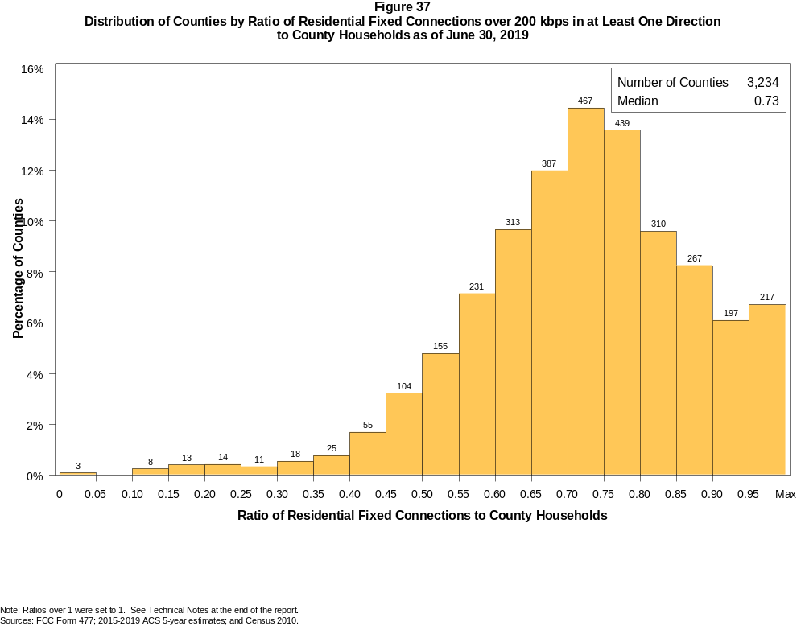

Figure 38
Distribution of Counties by Ratio of Residential Fixed Connections over 200 kbps in at Least One Direction
to County Households by Technology as of June 30, 2019

 | Ratio of Residential Fixed Connections to County Households
Technology | Zero | Greater than 0 and no more than 5% | Greater than 5 and no more than 10% | Greater than 10 and no more than 20% | Greater than 20 and no more than 30% | Greater than 30 and no more than 40% | Greater than 40 and no more than 50% | Greater than 50 and no more than 60% | Greater than 60 and no more than 80% | Greater than 80 and no more than 100% | 100% or more
aDSL | 1.5 | 7.5 | 9.8 | 31.4 | 25.5 | 13.8 | 6.2 | 2.3 | 1.6 | 0.2 | 0.2
sDSL | 94.3 | 5.6 | 0.1 | 0.0 | 0.0 | 0.0 | 0.0 | 0.0 | 0.0 | 0.0 | 0.0
Other Wireline | 93.9 | 6.0 | 0.1 | 0.0 | 0.0 | 0.0 | 0.0 | 0.0 | 0.0 | 0.0 | 0.0
Cable Modem | 11.3 | 7.3 | 6.0 | 12.9 | 12.9 | 12.5 | 11.8 | 11.8 | 11.4 | 1.5 | 0.6
FTTP | 15.5 | 44.2 | 11.1 | 11.7 | 6.6 | 3.4 | 2.5 | 2.1 | 2.4 | 0.3 | 0.1
Satellite | 0.4 | 64.2 | 22.9 | 10.9 | 1.3 | 0.3 | 0.0 | 0.0 | 0.0 | 0.0 | 0.0
Fixed Wireless | 14.8 | 60.5 | 12.5 | 8.0 | 2.6 | 1.1 | 0.3 | 0.1 | 0.1 | 0.0 | 0.1
Total | 0.1 | 0.0 | 0.0 | 0.6 | 0.8 | 1.3 | 4.9 | 11.9 | 49.7 | 26.3 | 4.4

¹ Power Line and Other are summarized with Other Wireline. See Technical Notes at the end of the report for a description of Form 477 technology categories and other reporting requirements.
Note: Figures may not sum to totals due to rounding.
Sources: FCC Form 477; 2015-2019 ACS 5-year estimates; and Census 2010.

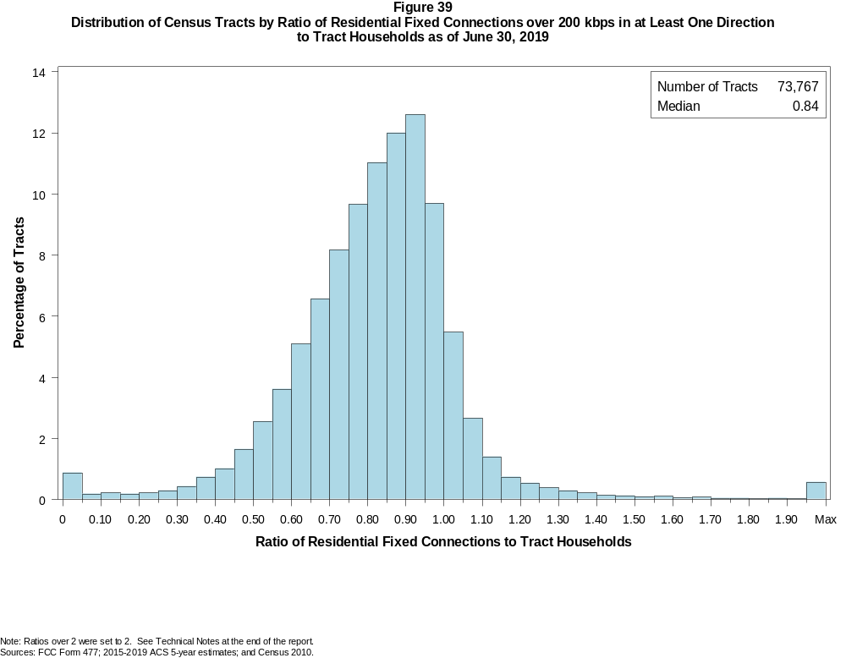

Figure 40
Distribution of Census Tracts by Ratio of Residential Fixed Connections over 200 kbps in at Least One Direction
to Tract Households by Technology as of June 30, 2019

 | Ratio of Residential Fixed Connections to Tract Households
Technology | Zero | Greater than 0 and no more than 5% | Greater than 5 and no more than 10% | Greater than 10 and no more than 20% | Greater than 20 and no more than 30% | Greater than 30 and no more than 40% | Greater than 40 and no more than 50% | Greater than 50 and no more than 60% | Greater than 60 and no more than 80% | Greater than 80 and no more than 100% | 100% or more
aDSL | 3.5 | 25.2 | 16.0 | 26.0 | 16.5 | 7.4 | 2.9 | 1.4 | 0.8 | 0.2 | 0.2
sDSL | 99.3 | 0.7 | 0.0 | 0.0 | 0.0 | 0.0 | 0.0 | 0.0 | 0.0 | 0.0 | 0.0
Other Wireline | 99.0 | 0.8 | 0.1 | 0.1 | 0.0 | 0.0 | 0.0 | 0.0 | 0.0 | 0.0 | 0.0
Cable Modem | 4.8 | 2.7 | 1.5 | 3.6 | 5.2 | 10.0 | 15.4 | 19.5 | 27.1 | 8.2 | 2.0
FTTP | 34.1 | 20.9 | 8.8 | 11.8 | 7.9 | 5.9 | 4.7 | 2.9 | 2.5 | 0.4 | 0.1
Satellite | 23.8 | 65.9 | 5.5 | 3.7 | 0.8 | 0.2 | 0.0 | 0.0 | 0.0 | 0.0 | 0.0
Fixed Wireless | 68.5 | 24.7 | 3.0 | 2.3 | 0.9 | 0.4 | 0.2 | 0.1 | 0.1 | 0.0 | 0.0
Total | 0.8 | 0.1 | 0.2 | 0.4 | 0.5 | 1.2 | 2.7 | 6.2 | 29.5 | 45.4 | 13.0

¹ Power Line and Other are summarized with Other Wireline. See Technical Notes at the end of the report for a description of Form 477 technology categories and other reporting requirements.
Note: Figures may not sum to totals due to rounding.
Sources: FCC Form 477; 2015-2019 ACS 5-year estimates; and Census 2010.

Figure 41
Percentage of Developed Census Blocks with Residential Fixed Service by Technology as of June 30, 2019
(Internet Access Service over 200 kbps in at least one direction)

 | Number of Providers
Technology | Zero | One | Two | Three | Four | Five | Six | Seven or More
aDSL | 22.4 | 75.1 | 2.4 | 0.1 | 0.0 | 0.0 | 0.0 | 0.0
sDSL | 99.5 | 0.5 | 0.0 | 0.0 | 0.0 | 0.0 | 0.0 | 0.0
Other Wireline¹ | 99.2 | 0.8 | 0.0 | 0.0 | 0.0 | 0.0 | 0.0 | 0.0
Cable Modem | 84.9 | 14.6 | 0.5 | 0.0 | 0.0 | 0.0 | 0.0 | 0.0
FTTP | 72.2 | 26.2 | 1.5 | 0.1 | 0.0 | 0.0 | 0.0 | 0.0
Satellite | 0.0 | 0.1 | 0.9 | 98.9 | 0.0 | 0.0 | 0.0 | 0.0
Fixed Wireless | 50.8 | 28.6 | 13.8 | 5.6 | 1.0 | 0.2 | 0.0 | 0.0
aDSL and/or Cable Modem and/or FTTP | 14.3 | 65.8 | 17.9 | 1.9 | 0.1 | 0.0 | 0.0 | 0.0
Any Technology | 0.0 | 0.1 | 0.1 | 4.0 | 14.7 | 41.3 | 25.0 | 14.8

¹ Power Line and Other are summarized with Other Wireline. See Technical Notes at the end of the report for a description of Form 477 technology categories and other reporting requirements.
Note: Figures may not sum to totals due to rounding. The number of providers in a census block does not necessarily reflect the number of choices available to a particular household, and does not
purport to measure competition. Providers may list a census block on Form 477 if service can be provided to at least one location in the block. Developed census blocks are those with housing units
based on the 2010 census.
Sources: FCC Form 477 and Census 2010.

Figure 42
Distribution of Counties by Ratio of Residential Fixed Connections to County Households by State as of June 30, 2019
(Connections over 200 kbps in at least one direction)

 |  | Ratio of Residential Fixed Connections over 200 kbps in at Least One Direction to County Households
State | Counties | Zero | Greater than 0 and no more than 5% | Greater than 5 and no more than 10% | Greater than 10 and no more than 20% | Greater than 20 and no more than 30% | Greater than 30 and no more than 40% | Greater than 40 and no more than 50% | Greater than 50 and no more than 60% | Greater than 60 and no more than 80% | Greater than 80 and no more than 100% | 100% or more
Alabama | 67 | 0 | 0 | 0 | 0 | 0 | 0 | 14 | 12 | 31 | 10 | 0
Alaska | 29 | 0 | 0 | 0 | 1 | 0 | 2 | 2 | 2 | 9 | 10 | 3
American Samoa | 5 | 2 | 0 | 0 | 0 | 2 | 0 | 1 | 0 | 0 | 0 | 0
Arizona | 15 | 0 | 0 | 0 | 0 | 0 | 0 | 0 | 2 | 5 | 8 | 0
Arkansas | 75 | 0 | 0 | 0 | 0 | 0 | 3 | 13 | 28 | 31 | 0 | 0
California | 58 | 0 | 0 | 0 | 0 | 0 | 0 | 1 | 0 | 12 | 42 | 3
Colorado | 64 | 0 | 0 | 0 | 0 | 0 | 0 | 2 | 7 | 19 | 22 | 14
Connecticut | 8 | 0 | 0 | 0 | 0 | 0 | 0 | 0 | 0 | 0 | 8 | 0
Delaware | 3 | 0 | 0 | 0 | 0 | 0 | 0 | 0 | 0 | 0 | 2 | 1
District of Columbia | 1 | 0 | 0 | 0 | 0 | 0 | 0 | 0 | 0 | 0 | 1 | 0
Florida | 67 | 0 | 0 | 0 | 0 | 0 | 0 | 0 | 6 | 17 | 32 | 12
Georgia | 159 | 0 | 0 | 0 | 0 | 3 | 5 | 13 | 29 | 63 | 38 | 8
Guam | 1 | 0 | 0 | 0 | 0 | 0 | 0 | 0 | 0 | 1 | 0 | 0
Hawaii | 5 | 0 | 0 | 0 | 0 | 0 | 0 | 0 | 0 | 0 | 2 | 3
Idaho | 44 | 0 | 0 | 0 | 0 | 0 | 0 | 1 | 4 | 23 | 11 | 5
Illinois | 102 | 0 | 0 | 0 | 0 | 0 | 0 | 3 | 19 | 60 | 20 | 0
Indiana | 92 | 0 | 0 | 0 | 0 | 0 | 0 | 0 | 14 | 60 | 18 | 0
Iowa | 99 | 0 | 0 | 0 | 0 | 0 | 0 | 0 | 4 | 82 | 12 | 1
Kansas | 105 | 0 | 0 | 0 | 0 | 0 | 0 | 3 | 6 | 75 | 21 | 0
Kentucky | 120 | 0 | 0 | 0 | 0 | 0 | 1 | 4 | 14 | 74 | 27 | 0
Louisiana | 64 | 0 | 0 | 0 | 0 | 0 | 1 | 10 | 14 | 29 | 10 | 0
Maine | 16 | 0 | 0 | 0 | 0 | 0 | 0 | 0 | 0 | 2 | 8 | 6
Maryland | 24 | 0 | 0 | 0 | 0 | 0 | 0 | 0 | 0 | 7 | 16 | 1
Massachusetts | 14 | 0 | 0 | 0 | 0 | 0 | 0 | 0 | 0 | 0 | 11 | 3
Michigan | 83 | 0 | 0 | 0 | 0 | 0 | 0 | 1 | 7 | 50 | 21 | 4
Minnesota | 87 | 0 | 0 | 0 | 0 | 0 | 0 | 1 | 2 | 57 | 25 | 2
Mississippi | 82 | 0 | 0 | 0 | 0 | 1 | 6 | 22 | 30 | 20 | 2 | 1
Missouri | 115 | 0 | 0 | 0 | 0 | 0 | 2 | 10 | 25 | 61 | 15 | 2
Montana | 56 | 0 | 0 | 0 | 0 | 0 | 0 | 0 | 3 | 31 | 20 | 2
Nebraska | 93 | 0 | 0 | 0 | 0 | 0 | 0 | 3 | 12 | 68 | 10 | 0

Figure 42 - Continued
Distribution of Counties by Ratio of Residential Fixed Connections to County Households by State as of June 30, 2019
(Connections over 200 kbps in at least one direction)

 |  | Ratio of Residential Fixed Connections over 200 kbps in at Least One Direction to County Households
State | Counties | Zero | Greater than 0 and no more than 5% | Greater than 5 and no more than 10% | Greater than 10 and no more than 20% | Greater than 20 and no more than 30% | Greater than 30 and no more than 40% | Greater than 40 and no more than 50% | Greater than 50 and no more than 60% | Greater than 60 and no more than 80% | Greater than 80 and no more than 100% | 100% or more
Nevada | 17 | 0 | 0 | 0 | 0 | 0 | 1 | 1 | 1 | 9 | 5 | 0
New Hampshire | 10 | 0 | 0 | 0 | 0 | 0 | 0 | 0 | 0 | 0 | 7 | 3
New Jersey | 21 | 0 | 0 | 0 | 0 | 0 | 0 | 0 | 0 | 0 | 18 | 3
New Mexico | 33 | 0 | 0 | 0 | 0 | 0 | 0 | 2 | 2 | 17 | 8 | 4
New York | 62 | 0 | 0 | 0 | 0 | 0 | 1 | 0 | 0 | 24 | 31 | 6
North Carolina | 100 | 0 | 0 | 0 | 0 | 0 | 0 | 0 | 3 | 48 | 42 | 7
North Dakota | 53 | 0 | 0 | 0 | 0 | 0 | 0 | 0 | 2 | 30 | 17 | 4
Northern Mariana Isl | 4 | 1 | 0 | 0 | 0 | 0 | 1 | 1 | 1 | 0 | 0 | 0
Ohio | 88 | 0 | 0 | 0 | 0 | 0 | 0 | 1 | 7 | 56 | 23 | 1
Oklahoma | 77 | 0 | 0 | 0 | 0 | 0 | 2 | 9 | 23 | 38 | 4 | 1
Oregon | 36 | 0 | 0 | 0 | 0 | 0 | 0 | 1 | 0 | 16 | 16 | 3
Pennsylvania | 67 | 0 | 0 | 0 | 0 | 0 | 0 | 0 | 1 | 38 | 25 | 3
Puerto Rico | 78 | 0 | 0 | 0 | 20 | 17 | 10 | 13 | 16 | 2 | 0 | 0
Rhode Island | 5 | 0 | 0 | 0 | 0 | 0 | 0 | 0 | 0 | 0 | 4 | 1
South Carolina | 46 | 0 | 0 | 0 | 0 | 0 | 0 | 2 | 10 | 20 | 11 | 3
South Dakota | 66 | 0 | 0 | 0 | 0 | 0 | 1 | 1 | 4 | 43 | 15 | 2
Tennessee | 95 | 0 | 0 | 0 | 0 | 0 | 0 | 1 | 16 | 65 | 13 | 0
Texas | 254 | 0 | 0 | 0 | 0 | 0 | 2 | 15 | 39 | 137 | 53 | 8
Utah | 29 | 0 | 0 | 0 | 0 | 0 | 0 | 0 | 1 | 6 | 16 | 6
Vermont | 14 | 0 | 0 | 0 | 0 | 0 | 0 | 0 | 0 | 0 | 10 | 4
Virgin Islands | 3 | 0 | 0 | 0 | 0 | 0 | 0 | 0 | 1 | 1 | 1 | 0
Virginia | 134 | 0 | 0 | 0 | 0 | 1 | 5 | 6 | 15 | 63 | 41 | 3
Washington | 39 | 0 | 0 | 0 | 0 | 0 | 0 | 1 | 0 | 14 | 22 | 2
West Virginia | 55 | 0 | 0 | 0 | 0 | 1 | 0 | 0 | 3 | 42 | 9 | 0
Wisconsin | 72 | 0 | 0 | 0 | 0 | 0 | 0 | 0 | 1 | 39 | 26 | 6
Wyoming | 23 | 0 | 0 | 0 | 0 | 0 | 0 | 1 | 0 | 11 | 10 | 1
Total | 3,234 | 3 | 0 | 0 | 21 | 25 | 43 | 159 | 386 | 1606 | 849 | 142

Note: Figures may not sum to totals due to rounding. See Technical Notes at the end of the report.
Sources: FCC Form 477; 2015-2019 ACS 5-year estimates (Households for U.S. and District of Columbia); Census 2010 (Households for Puerto Rico, American Samoa,
Guam, Northern Mariana Islands and U.S. Virgin Islands).

Figure 43
Distribution of Census Tracts by Ratio of Residential Fixed Connections to Tract Households by State as of June 30, 2019
(Connections over 200 kbps in at least one direction)

 |  | Ratio of Residential Fixed Connections over 200 kbps in at Least One Direction to Tract Households
State | Tracts | Zero | Greater than 0 and no more than 5% | Greater than 5 and no more than 10% | Greater than 10 and no more than 20% | Greater than 20 and no more than 30% | Greater than 30 and no more than 40% | Greater than 40 and no more than 50% | Greater than 50 and no more than 60% | Greater than 60 and no more than 80% | Greater than 80 and no more than 100% | 100% or more
Alabama | 1,179 | 5 | 0 | 0 | 0 | 11 | 49 | 92 | 188 | 446 | 320 | 68
Alaska | 167 | 1 | 0 | 1 | 4 | 1 | 7 | 4 | 13 | 51 | 64 | 21
American Samoa | 18 | 2 | 0 | 0 | 0 | 7 | 5 | 1 | 1 | 0 | 1 | 1
Arizona | 1,526 | 12 | 2 | 8 | 13 | 13 | 15 | 43 | 99 | 399 | 633 | 289
Arkansas | 686 | 1 | 0 | 0 | 0 | 7 | 44 | 102 | 140 | 271 | 111 | 10
California | 8,036 | 56 | 3 | 3 | 10 | 15 | 42 | 55 | 253 | 1,731 | 4,805 | 1,063
Colorado | 1,249 | 14 | 1 | 0 | 0 | 2 | 3 | 12 | 29 | 262 | 692 | 234
Connecticut | 829 | 4 | 0 | 0 | 1 | 0 | 1 | 5 | 15 | 137 | 528 | 138
Delaware | 215 | 1 | 0 | 0 | 0 | 1 | 0 | 0 | 4 | 50 | 100 | 59
District of Columbia | 179 | 1 | 0 | 0 | 0 | 0 | 0 | 1 | 6 | 57 | 75 | 39
Florida | 4,199 | 39 | 3 | 0 | 4 | 6 | 15 | 55 | 125 | 807 | 1,904 | 1,241
Georgia | 1,964 | 11 | 1 | 0 | 1 | 10 | 35 | 95 | 160 | 572 | 790 | 289
Guam | 56 | 6 | 0 | 0 | 3 | 4 | 4 | 4 | 7 | 8 | 6 | 14
Hawaii | 326 | 13 | 0 | 0 | 0 | 1 | 0 | 2 | 4 | 52 | 137 | 117
Idaho | 298 | 0 | 0 | 0 | 1 | 3 | 3 | 5 | 15 | 123 | 125 | 23
Illinois | 3,121 | 6 | 1 | 0 | 4 | 6 | 21 | 87 | 256 | 1,171 | 1,379 | 190
Indiana | 1,508 | 4 | 1 | 0 | 4 | 4 | 19 | 47 | 150 | 657 | 530 | 92
Iowa | 825 | 4 | 0 | 0 | 0 | 0 | 5 | 15 | 51 | 503 | 225 | 22
Kansas | 770 | 10 | 0 | 0 | 1 | 2 | 1 | 18 | 59 | 343 | 282 | 54
Kentucky | 1,115 | 10 | 0 | 1 | 0 | 7 | 17 | 36 | 87 | 429 | 465 | 63
Louisiana | 1,136 | 12 | 1 | 1 | 1 | 10 | 25 | 86 | 147 | 427 | 355 | 71
Maine | 351 | 0 | 0 | 0 | 0 | 0 | 0 | 0 | 3 | 83 | 172 | 93
Maryland | 1,394 | 9 | 0 | 0 | 0 | 1 | 7 | 20 | 50 | 272 | 777 | 258
Massachusetts | 1,471 | 12 | 0 | 0 | 2 | 1 | 2 | 2 | 22 | 240 | 942 | 248
Michigan | 2,767 | 29 | 1 | 2 | 10 | 11 | 51 | 139 | 252 | 827 | 1,235 | 210
Minnesota | 1,335 | 4 | 0 | 0 | 1 | 1 | 6 | 19 | 54 | 480 | 679 | 91
Mississippi | 661 | 4 | 0 | 0 | 0 | 7 | 40 | 120 | 144 | 226 | 105 | 15
Missouri | 1,393 | 4 | 0 | 0 | 2 | 6 | 31 | 80 | 169 | 480 | 525 | 96
Montana | 271 | 2 | 0 | 0 | 1 | 0 | 3 | 7 | 7 | 120 | 113 | 18
Nebraska | 532 | 3 | 0 | 1 | 0 | 0 | 2 | 8 | 39 | 227 | 217 | 35

Figure 43 - Continued
Distribution of Census Tracts by Ratio of Residential Fixed Connections to Tract Households by State as of June 30, 2019
(Connections over 200 kbps in at least one direction)

 |  | Ratio of Residential Fixed Connections over 200 kbps in at Least One Direction to Tract Households
State | Tracts | Zero | Greater than 0 and no more than 5% | Greater than 5 and no more than 10% | Greater than 10 and no more than 20% | Greater than 20 and no more than 30% | Greater than 30 and no more than 40% | Greater than 40 and no more than 50% | Greater than 50 and no more than 60% | Greater than 60 and no more than 80% | Greater than 80 and no more than 100% | 100% or more
Nevada | 683 | 5 | 0 | 1 | 0 | 1 | 9 | 14 | 24 | 180 | 328 | 121
New Hampshire | 294 | 2 | 0 | 0 | 0 | 0 | 0 | 0 | 3 | 28 | 183 | 78
New Jersey | 2,004 | 9 | 0 | 0 | 1 | 3 | 4 | 1 | 10 | 251 | 1,225 | 500
New Mexico | 499 | 2 | 4 | 2 | 4 | 6 | 16 | 20 | 57 | 184 | 168 | 36
New York | 4,900 | 79 | 1 | 5 | 13 | 17 | 24 | 32 | 126 | 1,373 | 2,377 | 853
North Carolina | 2,183 | 18 | 1 | 0 | 2 | 0 | 7 | 16 | 124 | 711 | 929 | 375
North Dakota | 205 | 0 | 0 | 0 | 0 | 0 | 0 | 3 | 9 | 96 | 72 | 25
Northern Mariana Isl | 22 | 2 | 0 | 0 | 0 | 2 | 4 | 6 | 1 | 7 | 0 | 0
Ohio | 2,946 | 8 | 0 | 0 | 4 | 2 | 16 | 70 | 202 | 1,171 | 1,300 | 173
Oklahoma | 1,046 | 0 | 0 | 2 | 4 | 15 | 38 | 77 | 194 | 373 | 267 | 76
Oregon | 827 | 2 | 0 | 0 | 0 | 0 | 2 | 7 | 22 | 227 | 498 | 69
Pennsylvania | 3,217 | 27 | 1 | 0 | 6 | 4 | 7 | 47 | 122 | 1,140 | 1,617 | 246
Puerto Rico | 903 | 18 | 61 | 111 | 190 | 123 | 126 | 81 | 41 | 47 | 29 | 76
Rhode Island | 241 | 1 | 0 | 0 | 0 | 0 | 0 | 2 | 1 | 27 | 169 | 41
South Carolina | 1,097 | 12 | 0 | 0 | 1 | 11 | 12 | 56 | 109 | 356 | 372 | 168
South Dakota | 222 | 0 | 0 | 0 | 2 | 0 | 2 | 4 | 20 | 100 | 74 | 20
Tennessee | 1,497 | 21 | 1 | 0 | 1 | 9 | 20 | 74 | 164 | 591 | 482 | 134
Texas | 5,253 | 39 | 0 | 4 | 5 | 27 | 90 | 212 | 517 | 1,735 | 1,900 | 724
Utah | 588 | 4 | 2 | 0 | 3 | 0 | 1 | 1 | 11 | 120 | 347 | 99
Vermont | 184 | 1 | 0 | 0 | 0 | 0 | 0 | 1 | 1 | 31 | 99 | 51
Virgin Islands | 29 | 0 | 0 | 0 | 1 | 2 | 1 | 2 | 9 | 10 | 3 | 1
Virginia | 1,895 | 23 | 0 | 2 | 2 | 14 | 30 | 59 | 120 | 465 | 908 | 272
Washington | 1,446 | 2 | 1 | 0 | 1 | 3 | 4 | 12 | 23 | 264 | 937 | 199
West Virginia | 484 | 0 | 0 | 1 | 3 | 1 | 9 | 21 | 49 | 219 | 146 | 35
Wisconsin | 1,393 | 3 | 1 | 0 | 1 | 4 | 2 | 6 | 40 | 536 | 727 | 73
Wyoming | 132 | 1 | 0 | 0 | 1 | 0 | 2 | 0 | 3 | 53 | 64 | 8
Total | 73,767 | 558 | 87 | 145 | 308 | 381 | 879 | 1,984 | 4,551 | 21,746 | 33,513 | 9,615

Note: Figures may not sum to totals due to rounding. See Technical Notes at the end of the report.
Sources: FCC Form 477; 2015-2019 ACS 5-year estimates (Households for U.S. and District of Columbia); Census 2010 (Households for Puerto Rico, American Samoa,
Guam, Northern Mariana Islands and U.S. Virgin Islands).

